SKILL PRACTICE TRACKER (DSA/TOPICS)
@CREATIVITY THINK (9483175986/7019689991)

ABSTRACT:
Skill Practice Tracker is a web-based application designed to help users monitor their daily practice across programming topics such as Data Structures, Algorithms, SQL, and other technical skills. The system enables users to log the number of problems solved or hours practiced, track streaks, calculate completion percentages, and visualize their progress through dashboard charts. Built using Django REST Framework for the backend and React for the frontend, the platform delivers a fast, responsive, and intuitive dashboard experience for students, interview candidates, and coding professionals..

INTRODUCTION OF THE PROJECT:
Consistent practice is crucial for mastering technical concepts such as DSA, system design, and coding fundamentals. Many learners struggle to track their progress, maintain continuity, and identify weak areas. Skill Practice Tracker solves these challenges by offering a centralized and interactive platform where users can add topics, log daily practice, review streaks, and analyze performance via weekly/monthly charts. Admins can maintain global templates and analyze platform-wide usage to improve learning workflows..

PROJECT OBJECTIVES:

• Allow users to add and manage topics/skills (e.g., Arrays, Trees, SQL Joins)
• Enable daily practice logging for problems solved or hours practiced
• Provide dynamic dashboards with weekly and monthly analytics
• Track streaks, completion percentages, and user consistency
• Maintain global topic templates for quick onboarding
• Provide simple admin controls for analytics and topic management
• Ensure smooth communication between backend (DRF) and frontend (React) using axios
• Deliver a fast, responsive UI with clear data visualizations using Recharts

PROBLEM OF THE STATEMENT:
Students preparing for coding interviews often struggle to track daily practice activities, leading to irregular study habits and inefficient revision patterns. Manual methods such as notebooks or spreadsheets become inconsistent and lack analytical insights. The Skill Practice Tracker addresses these issues by automating the tracking process, offering structured topic organization, monitoring streaks, and presenting graphical analytics to help learners improve their practice discipline and overall preparation strategies..

MOTIVATION OF THE PROJECT:
• To help coding learners maintain consistent practice
• To track progression across various DSA and technical topics
• To provide motivational streaks and completion indicators
• To simplify revision planning based on performance analytics
• To support learners with a personalized and interactive dashboard
• To reduce scattered tracking using notebooks or external apps
• To improve visibility of weak topics through structured logging

BLOCK DAIGRAM OF PROJECT:

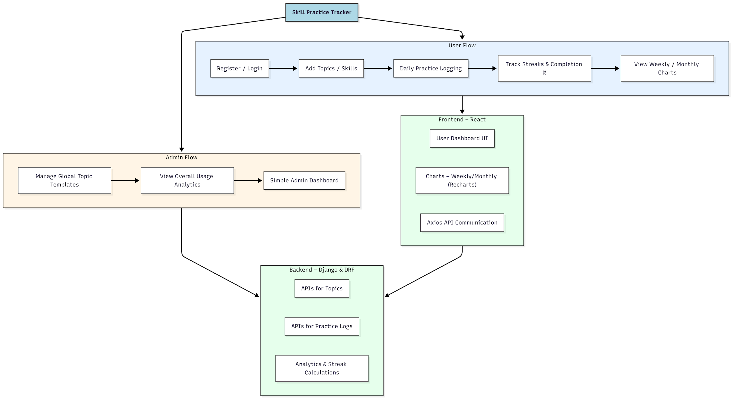

WORKING OF THE PROJECT:
Users start by registering and adding topics or skills they want to practice. Each day, they log how many coding problems they solved or the number of hours practiced. The system stores these logs and automatically calculates streaks, completion percentages, and cumulative progress. A dynamic dashboard displays weekly and monthly charts to help users visualize their practice trends. Admins can create global topic templates for easy onboarding, monitor platform-wide analytics, and ensure smooth functioning through a minimal admin dashboard..

SOFTWARE REQUIREMENT:
- Backend:
  - Python 3.x
  - Django
  - Django REST Framework
  - SQLite/PostgreSQL
- Frontend:
  - Node.js and npm
  - React.js
  - Axios
- Development Tools:
  - Visual Studio Code
  - Postman (for testing APIs)
  - Git/GitHub (for version control)
- Server/Deployment (Optional):
  - Gunicorn, Nginx, or Heroku/AWS for hosting

ADVANTAGES OF THE PROJECT:

• Tracks daily practice habits easily
• Improves consistency with streak monitoring
• Helps identify strong and weak topic areas
• Dashboard charts provide visual insights
• Motivates learners through progress indicators
• Simple UI for managing topics and logs
• Supports both beginners and advanced learners
• Easy to extend with new features

APPLICATIONS OF THE PROJECT:
• DSA and coding interview preparation
• Technical skill development tracking
• Academic revision planning
• Self-learning and personal improvement
• Coaching centers / coding bootcamps
• Study groups tracking collective progress

REFERENCES:

- Django REST Framework Documentation — Django Software Foundation. Django Documentation. Available: https://docs.djangoproject.com/
- Django REST Framework. DRF Documentation. Available: https://www.django-rest-framework.org/
- React. React Official Documentation. Available: https://reactjs.org/docs/getting-started.html
- Redux. Redux Documentation. Available: https://redux.js.org/introduction/getting-started
- PostgreSQL Global Development Group. PostgreSQL Documentation. Available: https://www.postgresql.org/docs/
- MySQL. MySQL Reference Manual. Available: https://dev.mysql.com/doc/
- Git. Git Documentation. Available: https://git-scm.com/doc
- Node.js. Node.js Documentation. Available: https://nodejs.org/en/docs/
- Axios. Axios Documentation. Available: https://axios-http.com/docs/intro
- Socket.io Documentation – https://socket.io/docs/

